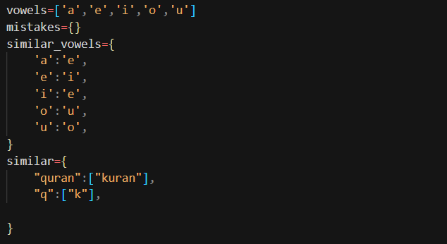

List of vowels created

Dictionary of similar sounding vowels created

In first for loop we are counting the number of vowels in the string

After getting the count of vowels we are getting the index of the vowels in the try block and storing the vowel index in vol_idx

Now that we have the index at which the vowel is present then we would be changing the vowel with similar sounding vowel

**BUT we made a thresholding to the vowels we need to change based on the observations**

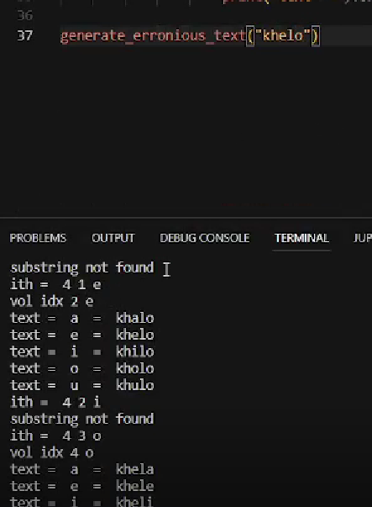

**Like you can see here the original word passed to the function is “KHELO” which in the first output became “KHALO”**

**Here the whole meaning of the word changed by changing one letter of the word**

**We did multiple tests and came to conclusion that changing letter with EVERY VOWEL should be done only after if the vol_idx is getter or equal to the half of the length of the string to keep its meaning intact.**

**WHICH MEANS:**

**“KHELO”**

**Can not be changed to :**

**“KHALO”**

**RATHER:  
“KHELA”**

**As A is the last letter and index is greater than half.**

**While we didn’t stop with this testing :**

**rather we further checked for the SIMILAR SOUNDING VOWELS**

**and considered that it’s okay to interchange vowels before the length of half the size of the string with similar sounding vowels.**

**Which means :**

**“KHELO”**

**Could be now**

**“KHILO”**

**Which sounds more like the original word.**

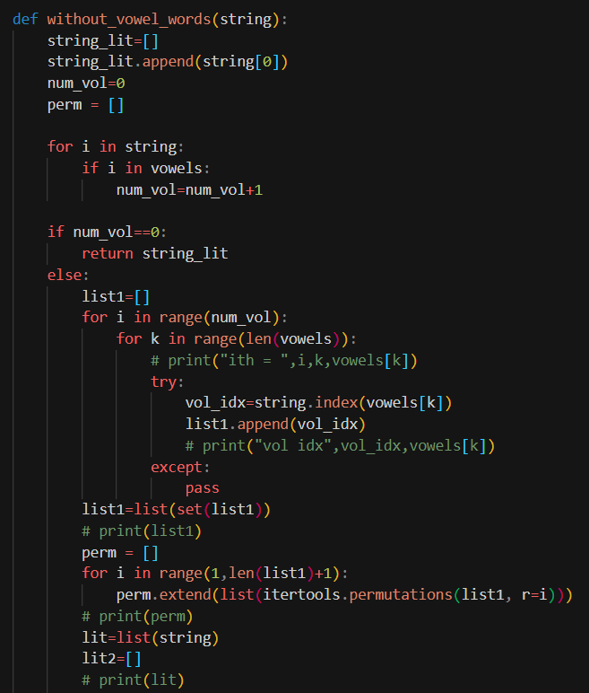

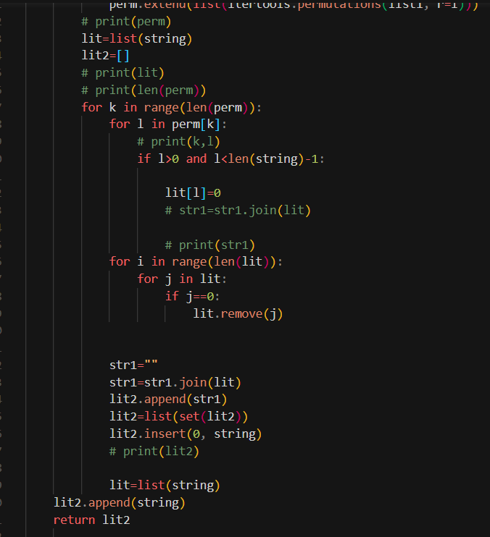

**What this method does is converts the words by removing vowels one by one creating all the possible words without vowels:**

**KHELO -> KHLO,KHEL,KHL**

**Where we first removed E , keeping E and removing O, and at last removing all vowels.**

**HAVING KHELO BECOMES ALL POSSIBLE WORDS WITH SHORTFORMS OR DIFFERENT STYLE OF WRITING KHELO   
WHICH CAN BE FURTHER INTERCHANGED TO GET THE ORIGINAL WORD.**